EE 564-REPORT OF PROJECT 2

Motor Winding Design & Analysis

Ali GEZER – 1876135

Contents

INTRODUCTION 3

Q1) Winding Design 3

Number of poles 3

Type of winding (integral, fractional, single layer, double layer etc.) 3

Winding diagram 3

Winding factors (including first few harmonics) 3

Number of turns, and wire size 4

Fill factor 4

Winding connection (delta-wye) 4

Aimed voltage and current ratings 4

The MMF waveform for two different instants 4

Q2) Motor Parameter Estimation 5

Axial length for the lamination 5

An airgap clearance value (reducing the rotor diameter appropriately) 5

The specific magnetic loading and also the flux densities in stator teeth, stator back core 5

The specific electric loading 6

The approximate torque and speed 6

The equivalent circuit parameters 6

The approximate core and copper losses 7

Q3) Detailed Analysis & Verification 7

Torque-Speed Characteristics 7

Flux density distribution at different conditions 8

Current waveforms at rated conditions 8

Efficiency curves 8

Equivalent circuit parameters 9

Effect of skewing etc. 9

CONCLUSION 10

# INTRODUCTION

In this project, it is asked to design and analyze an induction motor winding with a selected lamination. In the winding design part; Number of poles, Type of winding (integral, fractional, single layer, double layer etc.), Winding diagram, Winding factors (including first few harmonics), Number of turns, and wire size, Fill factor, Winding connection (delta-wye), Aimed voltage and current ratings are investigated. On the other hand; specific magnetic loading, the flux densities in stator teeth, stator back core, the specific electric loading, the approximate torque and speed, the equivalent circuit parameters, the approximate core and copper losses at the rated operating conditions are investigated in the Motor Parameter Estimation part. In last part, using a computer tool, the analytical designs will be tried to verify.

# Q1) Winding Design

It is chosen the lamination named as [ks(10)](https://github.com/odtu/ee564-2018/blob/master/Project2/ks(10).pdf) in the project folder by Kienle Spiess. The lamination has 36 slots in stator, 30 slots in rotor, and its stator inner diameter(Di) is 50 mm.

## Number of poles

Considering the Di is just 50 mm, a high synchronous speed (easy to handle in aspect of mechanic) assumed as acceptable. Therefore, Number of poles is chosen as 4 (2 pole pairs). Resulting Ns=1500rpm.

## Type of winding (integral, fractional, single layer, double layer etc.)

An integral, single layer, full pitch winding is designed.

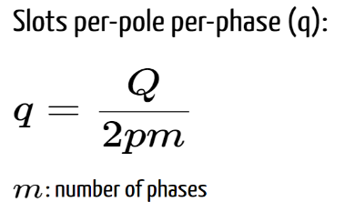q=36/(2*2*3)=3 (integer)

## Winding diagram

|  |  |  |  |  |  |  |  |  |  |  |  |  |  |  |  |  |  |  |
| --- | --- | --- | --- | --- | --- | --- | --- | --- | --- | --- | --- | --- | --- | --- | --- | --- | --- | --- |
| Slot No: | 1 | 2 | 3 | 4 | 5 | 6 | 7 | 8 | 9 | 10 | 11 | 12 | 13 | 14 | 15 | 16 | 17 | 18 |
|  | +A1 | +A2 | +A3 | -C1 | -C2 | -C3 | +B1 | +B2 | +B3 | -A1 | -A2 | -A3 | +C1 | +C2 | +C3 | -B1 | -B2 | -B3 |
| Slot No: | 19 | 20 | 21 | 22 | 23 | 24 | 25 | 26 | 27 | 28 | 29 | 30 | 31 | 32 | 33 | 34 | 35 | 36 |
|  | +A1 | +A2 | +A3 | -C1 | -C2 | -C3 | +B1 | +B2 | +B3 | -A1 | -A2 | -A3 | +C1 | +C2 | +C3 | -B1 | -B2 | -B3 |

Table 1

## Winding factors (including first few harmonics)

|  |  |  |  |  |  |  |  |  |
| --- | --- | --- | --- | --- | --- | --- | --- | --- |
| |  |  | | --- | --- | | 1st | 0,95984 | | 3rd | 0,66697 | | 5th | 0,21815 | | 7th | -0,17683 |   Table 2 |
|  |
|  |

## Number of turns, and wire size

Comparing the awg cables in attached excel sheet and throughout the RMxprt analysis, it is decided to go on with awg-27 with diameter size = 0.361 mm. It is seen that, Magnetic Loading (Bav) directly related with Number of turn per slot(Ns) and phase current. With an aim of having around 1 T as magnetic loading value, Ns is decided as 162.

## Fill factor

%60

## Winding connection (delta-wye)

Y (wye) connection is choosen. Note that 3rd harmonic is eliminated.

## Aimed voltage and current ratings

380 V – 0.85 A

## The MMF waveform for two different instants

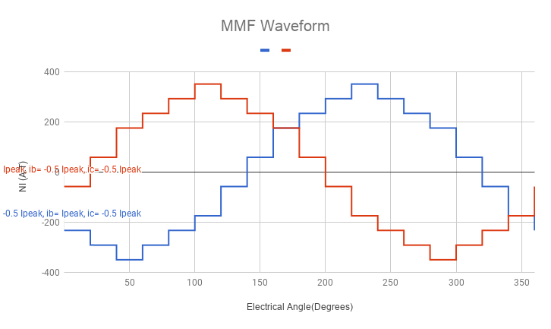

Figure 1: MMF waveform

The above figure shows the MMF waveforms for two different instants;

|  |  |  |
| --- | --- | --- |
| Ia | Ib | Ic |
| 1,202082 | -0,60104 | -0,60104 |

The red plot:

|  |  |  |
| --- | --- | --- |
| Ia | Ib | Ic |
| 1,202082 | -0,60104 | -0,60104 |

The blue plot:

# Q2) Motor Parameter Estimation

## Axial length for the lamination

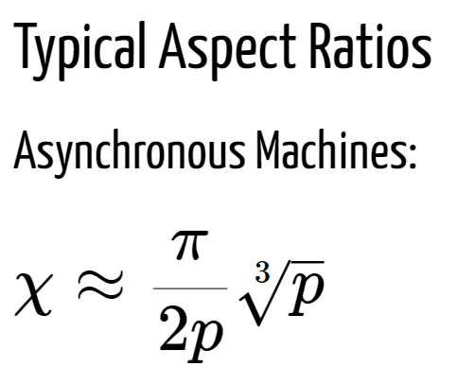

Using the formulas, L’ = 0.4945 mm

Where Di=50 mm

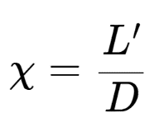

## An airgap clearance value (reducing the rotor diameter appropriately)

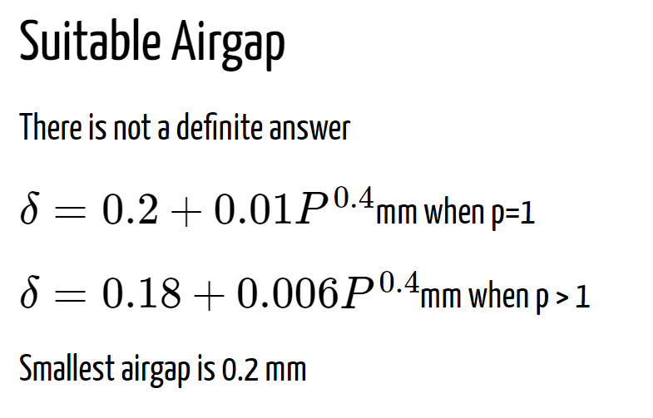

With the help of the information in left side,

Airgap=0.2472 where P=420 W

## The specific magnetic loading and also the flux densities in stator teeth, stator back core

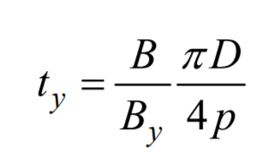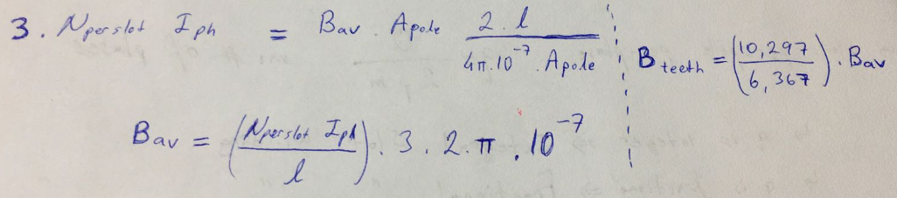Using the above formulas, The specific magnetic loading and also the flux densities in stator teeth can be calculated. On the other hand, the flux density in the stator back core is calculated with the right side formula. The results are given in attached excel sheet.

## The specific electric loading

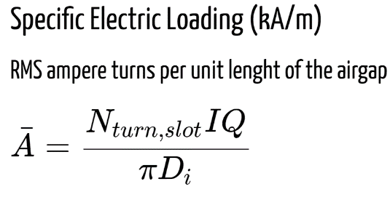 Using the left side formula, the specific Electric Loading is calculated as 31.5745 kA/m. The result is verified with the RMxprt tool as shown below.

## The approximate torque and speed

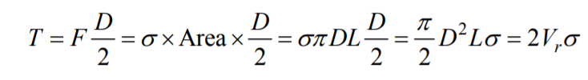

Using the above formula, torque is calculated as 1.55 Nm with the assumption of “the shear stress, σ=8 kPa”. Then, knowing that “P=T*w”, w is calculated as 162.5 rad/s where P=Po=420W. That results Nrated=776 rpm.

## The equivalent circuit parameters

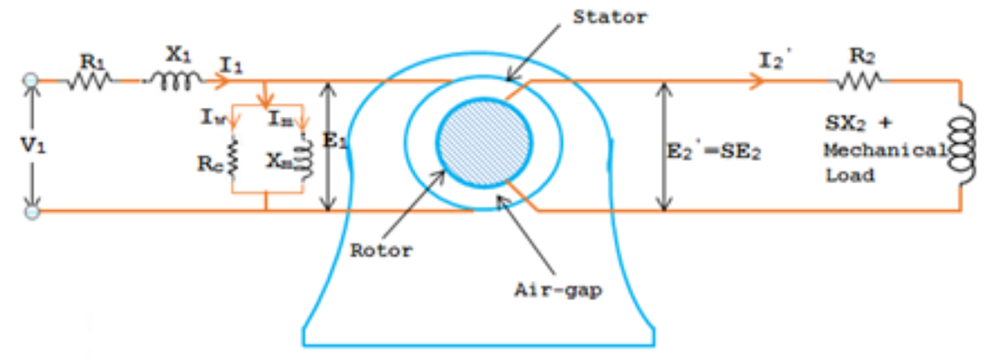The Figure-2 shows the equivalent circuit representation of an induction motor. Further simplifications may be conducted and the resulting representation can be obtained as shown in Figure-3.

Figure 2

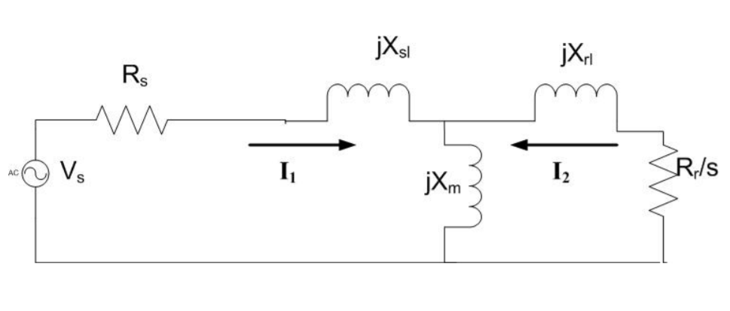The stator side parameters are calculated in the attached excel sheet. The others can be obtained throughout the RMxprt analysis.

Figure 3

## The approximate core and copper losses

An approximation for core losses can be conducted calculating total volume of core material and knowing its density. These would show core mass. One who knows the approximate core loss value for unit mass can calculate the core loss approximately. On the other hand, with obtained stator resistance, the copper loss on the stator side can be found. However, further details can be easily obtained throughout the RMxprt analysis.

# Q3) Detailed Analysis & Verification

Figure 5: Main Machine Model

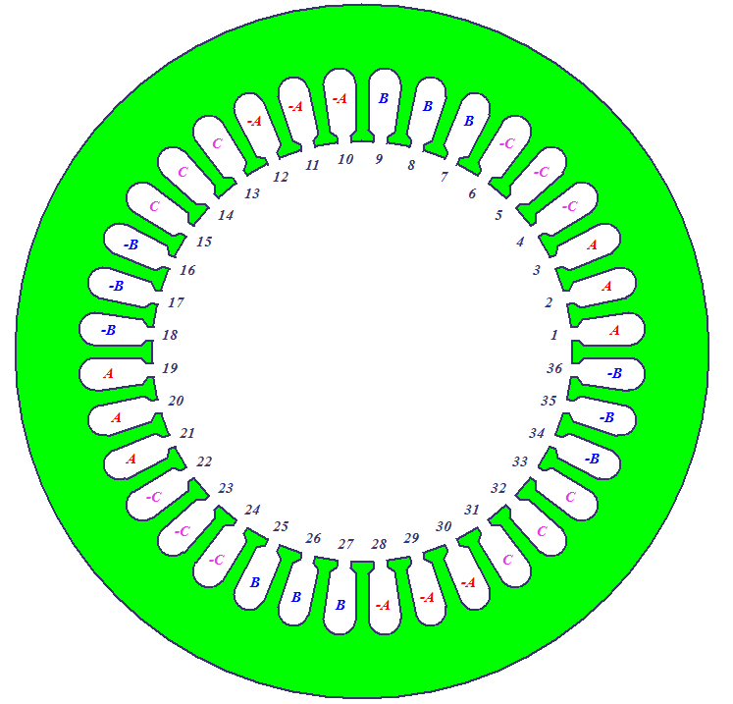The Design Sheet obtained from the RMxprt tool is attached.

Figure 4: Winding of the Model

## Torque-Speed Characteristics

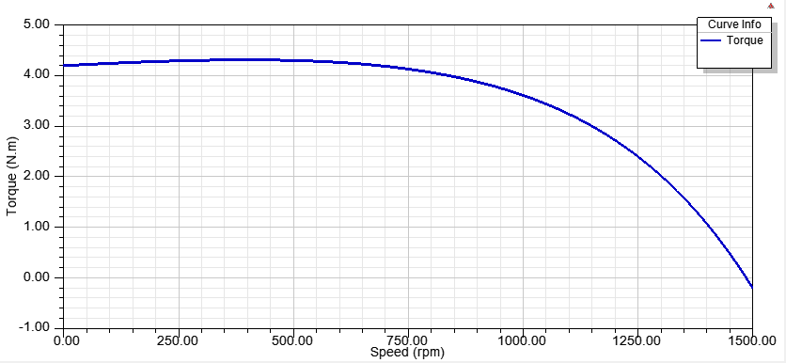

## Flux density distribution at different conditions

## Current waveforms at rated conditions

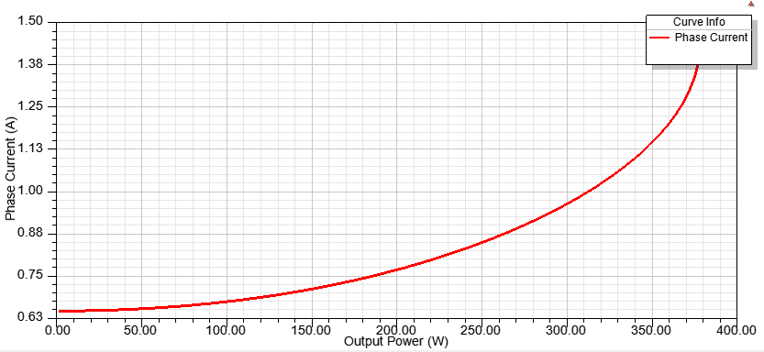

## Efficiency curves

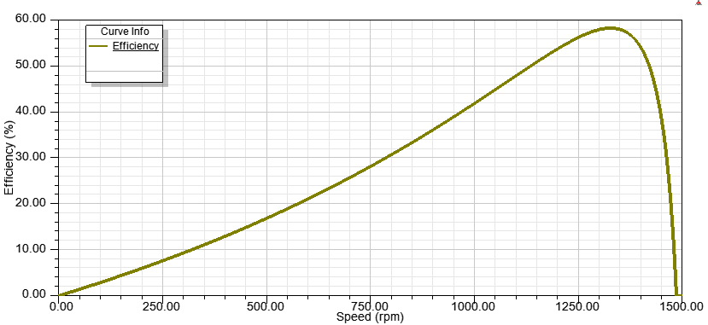

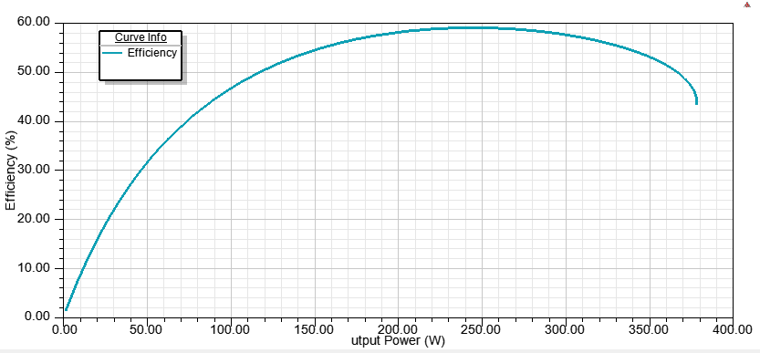

## Equivalent circuit parameters

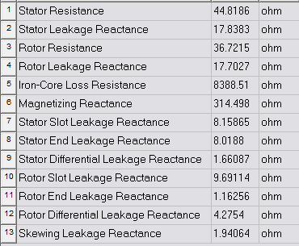

Note that skew width is 1 mm.

## Effect of skewing etc.

Skewing provides to avoid the cogging phenomenon and harmonics. With a skewed construction of rotor, magnetic locking or strong coupling of the machine may be prevented. Increase on rotor resistance may be considered as another effect of skewing. Thanks to this increase, start torque of the machine may be improved.

# CONCLUSION

In the winding design part, the main design parameters are specified. For winding factors, it is seen that the first few harmonics are actually not ignorable. Although the Y connection provides 3rd harmonic elimination, one may desire to eliminate one of the others. In such a case, one should use short-pitched winding design with double layer instead of full-pitched with single layer winding. For nth harmonic elimination, note that coil pitch should be equal to “(n-1) π/n”. On the motor parameters part, Magnetic Loading should be chosen very carefully because of the fact that the core material may be saturated. At this point it is important to notice that the saturation may occur even if the value of average flux density is acceptable. That is, (π/2)*Bav should be considered for a sinusoidal waveform. On the other hand, limiting point may be both the tooth flux density and the yoke flux density for saturation. Therefore, two of them must be checked in a design. Also, a strong dependence is observed between NI multiplication and Bav as can be expected. For the choose of NI multiplication, the only consideration is not Bav. For a design with extreme operating temperatures, NI selection may be limited with current carrying limitations. In addition, it is observed that the axial length has strong effect on the output power. However the design is conducted with typical value for asynchronous machines. At last, the tool RMxprt is a useful and rapid way of making some iterations for improvements/optimizations on a design, after a few basic analytical calculation.